LINUX PROGRAMMING: ASSIGNMENT-1: 20-09-2025
Submitted By : Urvija Kapila , 3C , Roll No: 11, ENG24CY0063

- What is Linux Operating System (OS)? List three pros and cons of it. (CO1)
Ans : Linux is an open-source operating system (OS) based on the Linux kernel, which is the main component that takes care of hardware and resource management. Linux was developed by Linus Torvalds in 1991 and has since become one of the most popular operating systems to date.
Some pros of Linux include:
• Open Source: The source code is free for use, modification, and redistribution. This has led to thousands of open-source variations such as Ubuntu, Fedora, Debian, Arch, and Red Hat.
• Multiuser & Multitasking: The system allows multiple users to use the system concurrently and run many tasks at the same time.
• High Security & Stability: Linux is known for its security and stability. Most web server systems, supercomputers, and cloud systems use Linux for this reason.
Some cons of Linux include:
• Limited Software Compatibility: Some commercially popular applications (like Adobe Photoshop and Microsoft Office, or some games) may not be available or may be harder to run on Linux.
• Hardware & Driver Support Woes: Although Linux does support most hardware, some devices (like printers, scanners, or brand-new graphics cards) may not yet function with Linux because the manufacturers have not created Linux drivers, creating usability issues.
• Fragmentation: Compatibility problems can arise because there are so many different distributions.
- Differentiate between Linux, Mac, Android, and Windows OS with at least six unique features. (CO1)
Ans: 1. Source & Licensing:
• Linux is open-source and free to use and modify.
• macOS is proprietary and closed-source (provided by Apple).
• Android is open-source (built from the Linux kernel), but is owned by Google.
• Windows is proprietary and closed-source (provided by Microsoft).
2. User Interface:
• Linux offers multiple desktop environments (GNOME, KDE, XFCE) and is customizable.
• macOS has a sleek, unified interface (Aqua + Dock) and has little customization option.
• Android has a touch-based UI optimized for mobile devices.
• Windows has a Start Menu + Taskbar and is a familiar UI for most desktops/laptops.
3. Software Ecosystem:
• Most Linux apps are free/open-source and there is not much commercial software.
• macOS has excellent support for creative/design software (Final Cut, Logic Pro).
• Android has a large ecosystem of apps via Google Play Store.
• Windows has the largest ecosystem of desktop software and game support.
4. Hardware Compatibility:
• Linux runs on a wide range of hardware from servers to IoT, but may have some driver issues.
• macOS will only run on Apple hardware (MacBooks, iMacs).
• Android will run on smartphones, tablets, smart TVs or wearables.
• Windows will run on almost all PCs, laptops, and also on some tablets.
5. Security:
• Linux is very secure with patching from a good community and is used in servers.
• macOS is secure with a combination of sandboxing and Gatekeeper, but is limited by Apple's control.
• Android is vulnerable due to fragmentation and third-party apps, althoughGoogle Play Protect is available.
• Windows is commonly targeted by malware, and good antivirus/security tools are typically needed.

- Why is Linux preferred for Mainframe Servers for legacy application? Give three out-of-the-box technical reasons. (CO1)
Ans: Linux is a popular choice for legacy mainframe applications because it enables businesses to take advantage of their mainframe's reliability and ability to scale, without being locked into the high cost of proprietary software. Businesses can use Linux to avoid the cost of license and skill deficiency of a legacy mainframe operating environment, and still get the benefits of the mainframe environment.
The three technical reasons why Linux is preferred in this scenario are:
• Virtualization for consolidation: The virtualization functionality of the mainframe (with a hypervisor such as z/VM) allows businesses to run thousands of Linux images on a single physical machine. This capability enables businesses to consolidate the many separate application workloads from their previous servers onto a single efficient mainframe, therefore reducing hardware, energy, and maintenance costs.
• Access to modern development tools: Running Linux on the mainframe opens a doorway to modern, open-source development. It provides developers with access to the tools and languages that are familiar to them in a distributed computing world, such as Git, Java (often with Spring), and Ansible, to manage and extend legacy applications. The process of modernizing an application is often easier than trying to adapt it within older proprietary applications.
• Cost-effective specialty processors: Mainframes provide the ability to use specialty processors, such as IBM's Integrated Facility for Linux (IFL), that are designed explicitly to run Linux workloads more cost-effectively than general-purpose processors. Because Linux workloads running on these processors typically are not figured into the mainframe's primary licensing cost and usually are much lower than the general-purpose processor costs, businesses can deliver legacy applications at a lower operational cost.
- Explain the structure of the Linux File System with proper diagram. Note: you can use the tree command to find it out. (CO2)
Ans:
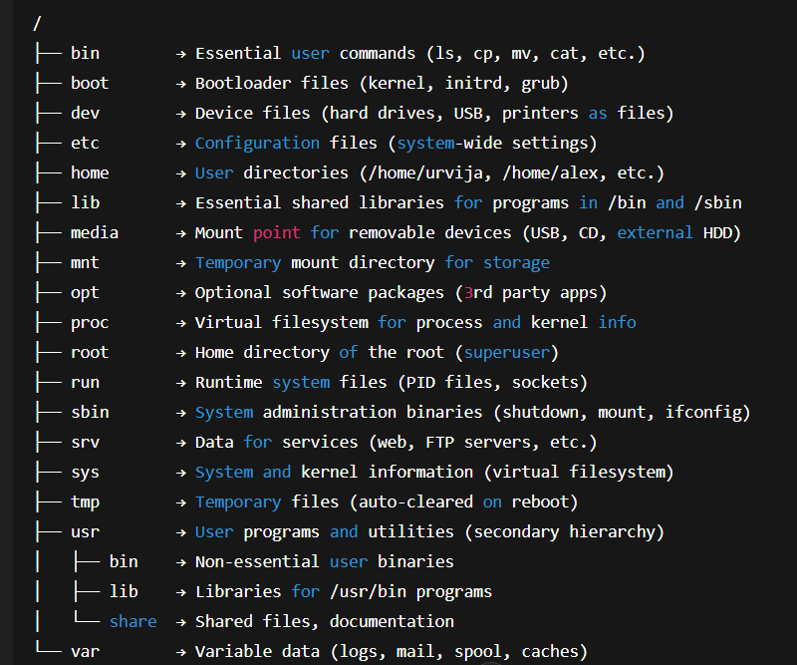
- / (Root): The base of the entire file system hierarchy. All other directories and files branch off from this point.
- /bin (Binaries): Contains essential, non-administrative command-line binaries and programs that all users can use, like ls, cp, and mv.
- /boot: Stores files needed to boot the operating system, including the Linux kernel and boot loader files.
- /dev (Devices): Contains device files that represent hardware devices. In Linux, devices are treated like files for easier management.
- /etc (Editable Text Configuration): Holds all the system-wide configuration files and is considered the "nerve center" of the Linux system.
- /home: The parent directory for all standard user home directories. Each user has a personal folder within this directory (e.g., /home/username).
- /lib (Libraries): Contains essential shared libraries and kernel modules needed by the binaries in /bin and /sbin.
- /mnt (Mount): A directory for temporarily mounted filesystems, which is often used for manual mounts by the system administrator.
- /proc (Processes): A virtual filesystem providing real-time system information, such as details about running processes and the kernel.
- /root: The dedicated home directory for the "root" superuser.
- /sbin (System Binaries): Contains command-line binaries for system administration and maintenance, which are typically only used by the root user.
- /tmp (Temporary): A directory for temporary files created by the system and users. Its contents are often cleared when the system reboots.
- /usr (Unix System Resources): A secondary hierarchy containing a majority of multi-user applications, libraries, documentation, and binaries.
- /var (Variable): Holds files with variable data, such as log files (/var/log), caches, and spool directories, that are expected to grow during system operation

- If Linux OS is open-source, how do companies like Red Hat still making money from it? Do a market study and answer properly. (CO2)
Ans : When organizations such as Red Hat leverage open-source products like Linux, they're not selling the code itself, but rather the value-added services created around the code. Most of this is accomplished through a subscription service model, where revenue is derived from support, training, and integration services instead of software licensing fees. This is the business model shared by the majority of the most successful open-source companies. Red Hat was the first open-source company whose revenue surpassed $1 billion, prior to its acquisition by IBM. A closer look on the market shows:
1. Enterprise subscriptions for stability and support
Corporations, unlike individual users, need rock-solid stability, expert support, and legal indemnification for mission-critical systems. Red Hat offers Red Hat Enterprise Linux (RHEL), a stable, hardened, and thoroughly tested version of the community-developed Linux Fedora.
- What they sell: A subscription that provides certified, enterprise-grade updates, security patches, bug fixes, and long-term support for years or even a decade.
- Why companies pay: To avoid the risks and costs of managing their own Linux distribution. They are willing to pay for the expertise, reliability, and guaranteed support from the creator of the OS, rather than relying on community forums for help.
2. Additional open-source products and platforms
Red Hat and other companies don't stop at just the OS. They create integrated software stacks that address the complex needs of large-scale, modern IT environments.
- What they sell: A portfolio of enterprise technologies, including Red Hat OpenShift (a container application platform), JBoss Middleware, and Ansible (automation software).
- Why companies pay: For a fully integrated and supported ecosystem. Forrester research has shown that partners can achieve high margins (up to 70%) on solutions and services built on top of Red Hat products like OpenShift.
3. Training and certifications
As open-source software becomes more common in enterprise IT, there is high demand for skilled professionals. Red Hat has a large, profitable business certifying and training professionals to use its products.
- What they sell: Certification programs, like the Red Hat Certified Engineer (RHCE) credential, and comprehensive training courses.
- Why companies pay: To ensure their IT staff have the necessary skills to manage their infrastructure effectively. A hiring manager is more likely to choose a certified professional for a critical role

- Write the command to display today’s date and time (i.e., current System time). (CO1)
Ans: The command to display today’s date and time is “date”.
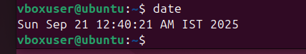
- Which command is used to check how long the system has been running? (CO1)
Ans: The command used to check how long the system has been running is “uptime” .
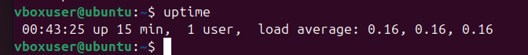
- What is the difference between shutdown -h now and halt? (CO1)
Ans: shutdown -h:
- This is the preferred command for a controlled system halt.
- It initiates a graceful shutdown, terminating processes and unmounting file systems cleanly.
- It broadcasts a warning message to logged-in users before starting the shutdown sequence.
- The now argument executes the shutdown immediately.
- Once the system is down, it typically halts or powers off, depending on system configuration.
Halt :
- This command is used to stop all CPU functions.
- On modern Linux systems (e.g., those using systemd), halt often behaves like poweroff, shutting down the system and cutting power.
- In older systems, it might simply halt the system, requiring a manual power-off.
- It does not include options for scheduling a shutdown or broadcasting messages to users.

- Compare init 0 and shutdown -h. Which is safer? Why? (CO1)
Ans: 1. init 0
- Meaning: Changes the system runlevel to 0 (halt state).
- Effect: Immediately stops all processes and powers off the machine.
- Limitation:
  - It doesn’t warn logged-in users.
  - It doesn’t allow scheduled shutdowns.
  - Some services may not gracefully terminate (risk of data loss).
shutdown -h
- Meaning: Shuts down the system and halts (-h) the CPU.
- Effect: Safely stops processes, syncs data, unmounts filesystems, and then powers off.
- Advantages:
  - Allows delayed shutdowns (e.g., shutdown -h +10 to halt after 10 minutes).
  - Sends a warning to all logged-in users.
  - Ensures clean termination of services and processes.

- A system administrator accidentally powers off a Server machine without shutting it down properly. What problems can occur to the said Server? (CO2)
Ans: When a server is powered off abruptly (without proper shutdown), several problems can occur:
1. File System Corruption
- Data being written to disk at the time of power loss may become incomplete or corrupted.
- Journaling file systems (like ext4, xfs) reduce risk, but corruption can still happen if metadata wasn’t fully written.
2. Data Loss in Memory (RAM)
- Anything stored in RAM but not yet written to disk is lost.
- This includes cached writes, unsaved database transactions, or in-memory configurations.
3. Database & Application Inconsistency
- Databases (MySQL, PostgreSQL, Oracle) may end up in an inconsistent state if they were mid-transaction.
- Applications relying on cached data or temporary files may also fail to restart properly.
4. Service Downtime & User Impact
- Abrupt shutdown can lead to unavailability of services (web server, mail server, etc.) for users.
- This may also break active network connections and cause client-side errors.
5. Hardware Stress & Disk Issues
- Sudden power loss stresses components like hard drives and SSDs, especially if write caches were active.
- Repeated incidents can shorten the hardware’s lifespan.

